This book review appeared in the ABA TYL Magazine, Spring 2019:
Reprinted with permission.

TYL

Breaking the Shield of Silence
Volume 23 Number 3
By Pervin R. Taleyarkhan
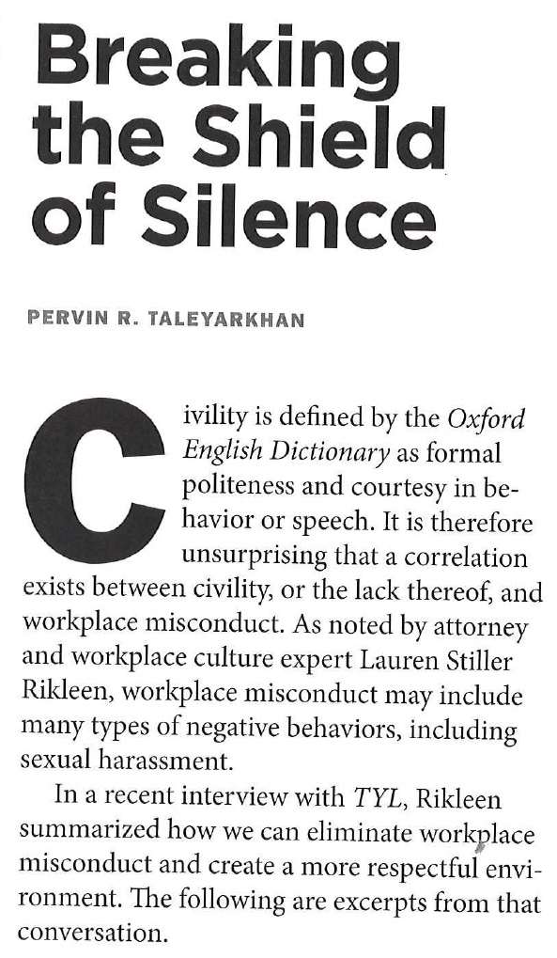
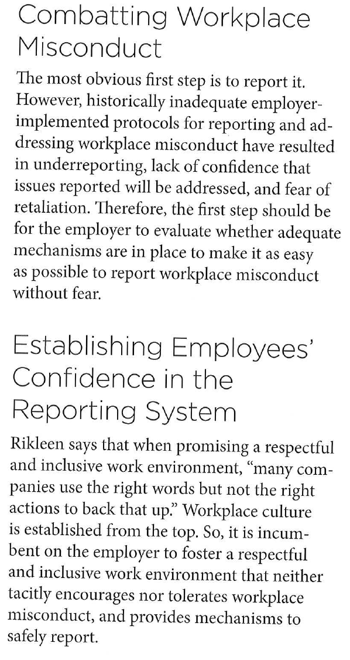

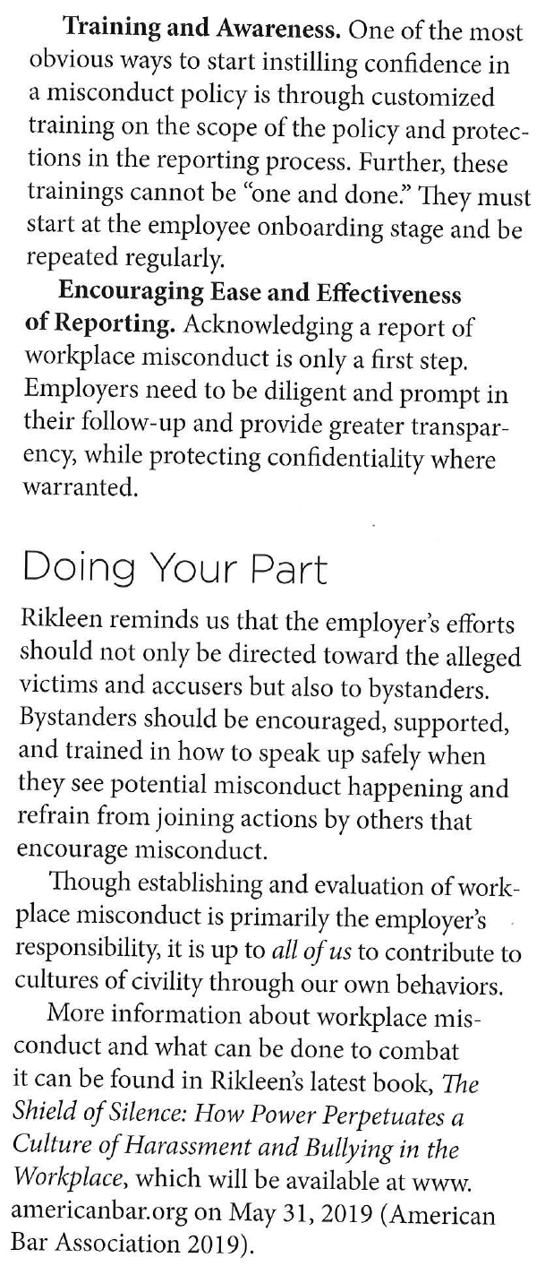

Lauren Stiller Rikleen

President, Rikleen Institute for Strategic Leadership

www.RikleenInstitute.com

508-259-3500

LRikleen@RikleenInstitute.com

